Colton Fire Department Corporation, Inc.
PO Box 304
Colton, NY 13625
Est. 1915

May 23, 2019

Any Interested Business/Person/Corporation

Dear Sir or Madam,

The Colton Volunteer Fire Department is holding the Rod Thomas Memorial 6 v 6 Soccer Tourney in South Colton on Saturday August 3rd, 2019. There will be Boys and Girls teams for a high school division and two Co-ed open divisions, 30 and under and 31+.

We (through the bearer of this letter) are soliciting donations for door and raffle prizes for the attendees and donations for the concession stand at the event or any other donation you would be willing to make. Please note that the Colton Fire Department Corporation is an exempt organization under New York State Law, Certificate No. EX-104865, dated June 1, 1971

If you have any questions, feel free to call me at 315-262-2072 or email me at anglejeff@aol.com. Ms. Sharon Andrews will be the bearer of this letter and is authorized to receive the donations.

Respectfully,

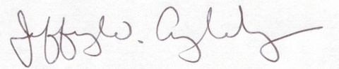
Jeffery W. Angleberger
President

Cc: Angel Angleberger – Secretary
Jake Crosley - Treasurer

